Desk Number________

Student Number_______________________

Student Name_______________________

**School of Science and Engineering**

**FINAL EXAMINATION**

Semester 2, Aug, 2020

**CSC1001 Introduction to Computer Science**

Examination Duration: 120 minutes

Reading Time: 10 minutes

This examination has __3__ questions.

**Exam Conditions:**

This is a FORMAL Examination

This is a RESTRICTED OPEN BOOK Exam. Maximum of one (1) sheet of handwritten or printed notes double sided are permitted

**Materials Permitted In The Exam Venue:**

Maximum of one (1) sheet of handwritten or printed notes double sided, a scientific calculator without the functionalities of programming and file storage and a paper-based dictionary are permitted. **NO OTHER MATERIALS PERMITTED**

**Materials To Be Supplied To Students:**

1 × 12 Page Answer Booklet, one answer sheet for multiple choice questions.

**Materials To Be Handed in After Exam:**

After exam, only answer sheet for multiple choice questions and the answer booklet are to be handed in.

Question 1. (15 × 2% = 30%)

Pick the correct option in each of the following sub-questions. Note that only ONE option is correct.

* 1. Hexadecimal number 3FA9.B and binary number 11010110.001 equal to decimal numbers:

1. 16297.6875 and 428.125
2. 16553.6875 and 214.125
3. 16297.6875 and 214.125
4. 16553.625 and 428.125
   1. Concerning Python language, which of the following statements is correct?
5. The python interpreter is a tool to check grammar mistakes of python code
6. Object-Oriented Programming is a unique feature of Python
7. A program written in Python must be contained in a PY file, e.g. example.py
8. Python is a cross-platform language: Pythons programs written on Windows can also run on Linux and macOS
   1. The following function returns the index of the minimum value in the a array. What should be filled in the comment line (#①) ?

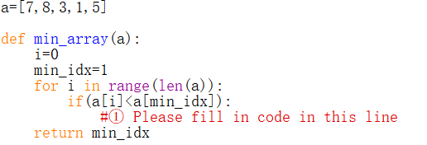

A: i=min_idx

B: a[min_idx]=a[i]

C: min_idx =a[min_idx]

D: min_idx =i

* 1. Consider the following program, which statement/s is/are correct?

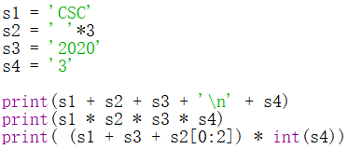

1. The output of the first print function is   
   CSC 2020 3
2. The output of the second print function does not exit.
3. The output of the third print function is  
   CSC2020CSC2020CSC2020
4. The output of the third print function does not exit.
   1. Concerning one python list, which of the following statement is correct?
5. List is immutable, which means we cannot change its value using index operator.
6. List can contain another python list as its element.
7. Lists are comparable and two lists are equal if their first elements are equal.
8. *list(5)* creates a list containing a single element 5.
   1. Concerning the object in Python, which of the following statements is incorrect?
9. Every object in Python has an unique ID.
10. The type of an object cannot be determined automatically by Python interpreter, programmer must define its data type.
11. Every variable is essentially a reference to an object.
12. The ID of an object may not be changed during the execution of the program.
    1. Concerning the following program, which of the following statements is correct?

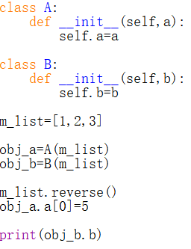

1. The output of the statement print(obj_b.b) is [1, 2, 3].
2. The output of the statement print(obj_b.b) is [5, 2, 3].
3. The output of the statement print(obj_b.b) is [3, 2, 1].
4. The output of the statement print(obj_b.b) is [5, 2, 1].
   1. Concerning class inheritance in Python, which of the following statements is incorrect?
5. Inheritance enables you to define a general class and later extend it to define more specialized classes.
6. A subclass may inherit data fields and methods from its superclass.
7. Inheritance models the is-a relationships, so all is-a relationships could be modelled using inheritance.
8. A subclass is not a subset of its superclass, usually it contains more information and methods than its superclass.
   1. What is the output of the following code?

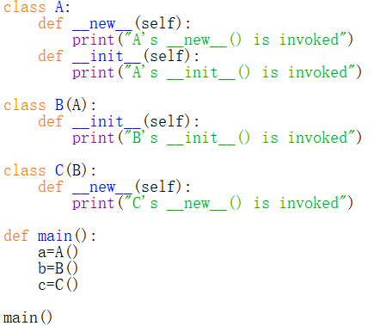

1. A's __new__() is invoked  
   A's __init__() is invoked  
   A's __new__() is invoked  
   B's __init__() is invoked  
   C's __new__() is invoked  
   B's __init__() is invoked
2. A's __new__() is invoked  
   A's __new__() is invoked  
   C's __new__() is invoked
3. A's __new__() is invoked  
   A's __new__() is invoked  
   B's __init__() is invoked  
   C's __new__() is invoked
4. A's __new__() is invoked  
   A's __init__() is invoked  
   B's __init__() is invoked  
   C's __new__() is invoked
   1. Concerning data structure and algorithm, which of the following statements is incorrect?
5. When evaluating an algorithm, we only need to measuring its running time.
6. Data structure concerns how to organize and access data.
7. An algorithm is a step-by-step procedure for performing some tasks in a finite amount of time.
8. When analyzing the running time of an algorithm, two commonly used approaches are experimental analysis and asymptotic analysis.
   1. Concerning algorithm analysis, which of the following statements is not correct?
9. The result of asymptotic analysis depends on the hardware and software environment where you perform the algorithm.
10. An algorithm with a time complexity of O (1) is asymptotically better than an algorithm with a time complexity of O (n).
11. We can use the big O notation to order classes of functions by asymptotic growth rate and it is useful in the analysis of algorithms.
12. In algorithm analysis, we focus on the growth rate of the running time as a function of the input size.
    1. Concerning the following program

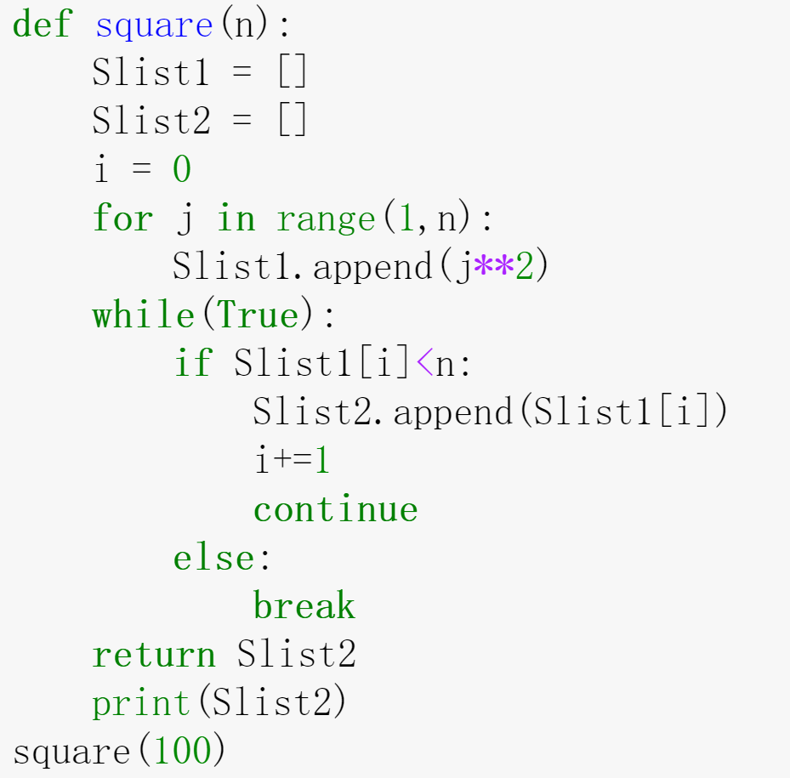

Which of the following statement/s is/are correct?

A. Function square() has only one return value.

B. Function square() uses a definite loop to return a list of numbers that are square less or equal to the input argument n.

C. The length of the list Slist2 has been set beforehand.

D. The result of the program is shown as following:

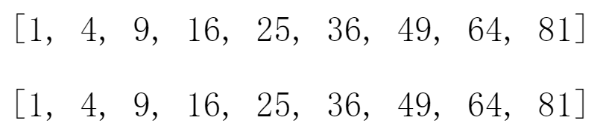.

* 1. Concerning stack and queue, which of the following statement is correct?

1. More than one element of a stack can be accessed simultaneously if necessary.
2. Elements can be inserted at any time in a queue, but only the element that has been in the queue the shortest can be next removed.
3. A stack can be accessed based on the “last in first out” principle and the time complexity of inserting an element into a stack is constant.
4. The time complexity of removing an element from a stack or a queue is linear.
   1. Concerning linked list, which of the following statement/s is incorrect?
5. Singly linked list is a collection of nodes that collectively form a linear sequence.
6. The tail node of a singly linked list has None as its next reference.
7. A node in a double linked list usually contains two references pointing to its previous and next node.
8. The time complexity of removing the tail node of a double linked list is quadratic.
   1. Concerning the search and sort algorithms, which of the following statement is NOT correct?
9. The time complexity of bubble sort is O(n2).
10. Binary search algorithm can be applied on an unsorted sequence.
11. The time complexity of quick sort is O(nlogn).
12. Binary search is usually more efficient than sequential search.

Question 2. (10 × 4% = 40%)

Pick the correct option/s in each of the following sub-questions. Note that there may be MULTIPLE correct options for each sub-question(one, two, three or four correct options all possible). With any wrong options will get 0 point for that problem, while missing any correct options will get half(2 points).

* 1. Which of the following is/are the python reserved word?

A. not B. fail

C. True D. in

* 1. Concerning recursion, which of the following statement/s is/are correct?

1. When a function makes two or more recursive calls, this function does not belong to multiple recursion.
2. A recursive algorithm should have one or more base cases which is or are non-recursive.
3. All the recursive calls are executed successively, that is, one will not be executed until the previous one finishes completely.
4. The base case in recursive algorithm can return nothing.
   1. Which of the following statement/s is/are correct?
5. If we open a file as open(file, mode='r'), we could write some texts in this file.
6. If we open a file and don't need it any more, we'd better close it by file.close().
7. We could read file by many different mode like by line, by size or by whole lines.
8. We could directly write text as many data fields like integer, boolean or float in a file.
   1. Given the program, which of the following statement/s is/are correct?

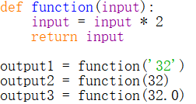

1. The data types of output1, output2, output3 are: str, int, float
2. output1 is exactly: 64
3. output2 is exactly: 64
4. output3 is exactly: 64
   1. Concerning the following program, which of the following statement/s is/are correct?

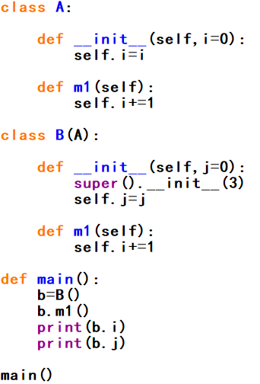

1. Class B() has two superclasses.
2. In class B(), the initializer of A() is accessed by calling function super().
3. Class B() has two data fields.
4. The output of b.i and b.j are 4 and 0.
   1. Concerning the following program, which of the following statement/s is/are correct?

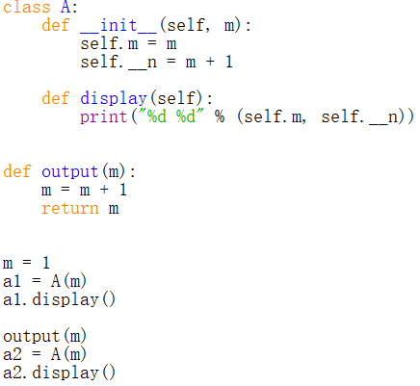

1. The value of global variable m will initially be set as 1, and then changed to 2.
2. Within the initializer of class A, the function display is invoked.
3. Data field n of class A() can only be accessed within definition of class A .
4. The output of this program is:  
    1 2  
    1 2
   1. Concerning the following program, which of the following statement/s is/are correct?

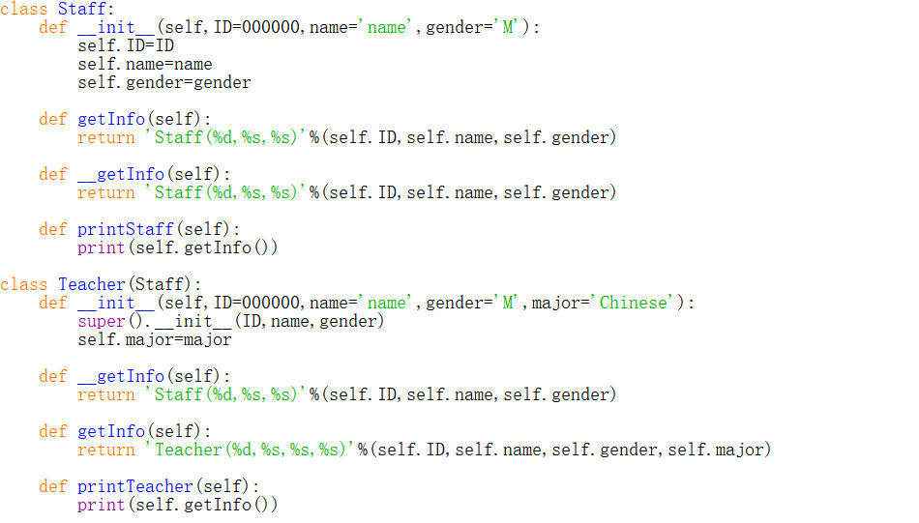

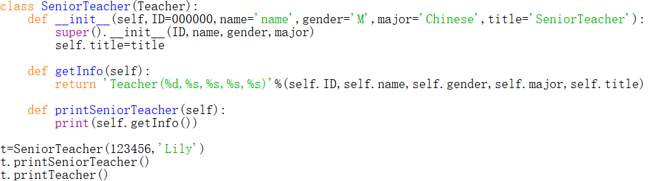

1. The output for this program is:  
    Teacher(123456,Lily,M,Chinese,SeniorTeacher)

Teacher(123456,Lily,M,Chinese)

1. The getInfo() method in SeniorTeacher() class has been overridden.
2. The __getInfo() method in Teacher() class is inherited from Staff class.
3. The t.printTeacher() method is actually invoke getInfo() method in SeniorTeacher() class.
   1. Concerning the class in Python, which of the following statement/s is/are correct?
4. In Python, everything (e.g. string, float number, list) is an object.
5. A class can only inherit one class, which is called single inheritance.
6. Dynamic binding decides which method is invoked at runtime when the method appears many times in the inheritance chain.
7. Every instance of a subclass is also an instance of its superclass, and vice versa.
   1. Concerning algorithm analysis, which of the following statement/s is/are incorrect?
8. The big-Oh notation allows us to say that a function f(n) is larger than or equal to another function g(n) up to a constant factor when n is large enough.
9. The big-Oh notation is usually used to characterize the running time of an algorithm in the asymptotic sense.
10. Function $6n^{3}+2n^{2}+2n$ is O($n^{3}$).
11. When we analyse an algorithm, we are usually interested in its average performance regardless of the input size.
    1. Let P stand for the push operation for stack and O stand for the pop operation for stack, what is the stack operation sequence that changes a string from “3 * a + b / c” to “3a * bc / +” ?   
       (For example, the operation sequence to change a string from “ABC” to “BCA” is PPOPOO)
12. PPPOOOPPOPPOOO
13. POPOPOPPOPPOOO
14. POPPOOPPOPOOPO
15. POPPOOPPOPPOOO

Question 3. (6%+10%+14% = 30%)

Answer the following questions.

* 1. The following program is to find the greatest common divisor (gcd) of two integers.

Sample input numbers: 12 and 14

Sample output: 2

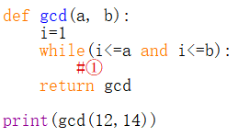

1. Please fill in the blank to implement the function required. (The fill-in codes could be more than one line)
2. Modify the program using recursive algorithm. The structure is provided as below.Please fill in the blanks.

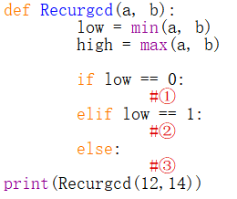

1. Write the output for the given program if the input numbers are updated as (21, 28).
   1. Concerning the following program

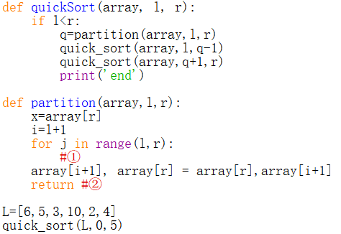

Answer the following questions:

1. This program is to sort a given list with ascending order(the output of the above program is [2,3,4,5,6,10]). Use quick sort to implement the sort. Please fill the blank ①② to complete the program. (The fill-in codes could be more than one line)
2. How many times the ‘end’ is printed in the program? Please draw the recursive trace for this program.
   1. Let a binary search tree (BST) is defined as follows:  
      The left subtree of a node contains only nodes with elements less than the node's element.  
      The right subtree of a node contains only nodes with elements greater than the node's element.  
      Both the left and right subtrees must also be binary search trees.
3. What’s the purpose of function check().

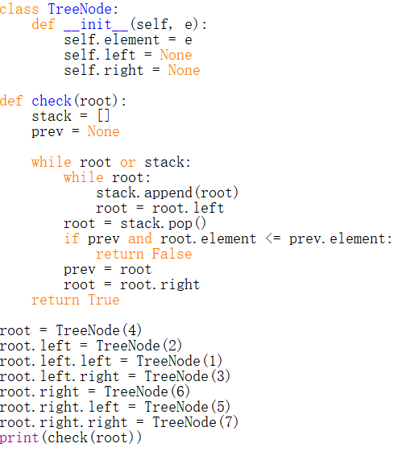

1. Please write the output of above program.
2. The code below is to implement Depth First Search (DFS) algorithm on a binary tree. The input t is the reference of tree root node. Please write the output of applying DFS on the tree created in Question (1).

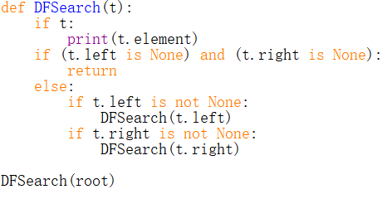

1. Write a function to find a node with maximum element from a binary search tree. (The fill-in codes could be more than one line)

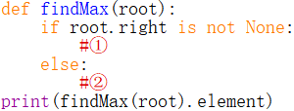

**END OF EXAMINATION**